Sean Hayden

12/4/2023

Seizure Detection with Mediapipe

The purpose of this project is to detect a seizure with mediapipe. This is done with the coordinates of the landmarks that are on the head and shoulders, then use them to calculate the speed and displacement of the body parts.

Firstly, we need to get the coordinates from the raw output, which is just a string with all of the x-y-z coordinates of all of the landmarks across the body. The landmarks for the left and right shoulder are 11 and 12 respectively, and landmarks 0 – 10 are on the face. For the purposes of this application, the landmarks we care about are 0 for the nose, 2 and 5 for the left and right eye, and 9 and 10 for the left and right mouth. The y coordinates of the shoulders are used for detection, as well as the x values for the head.

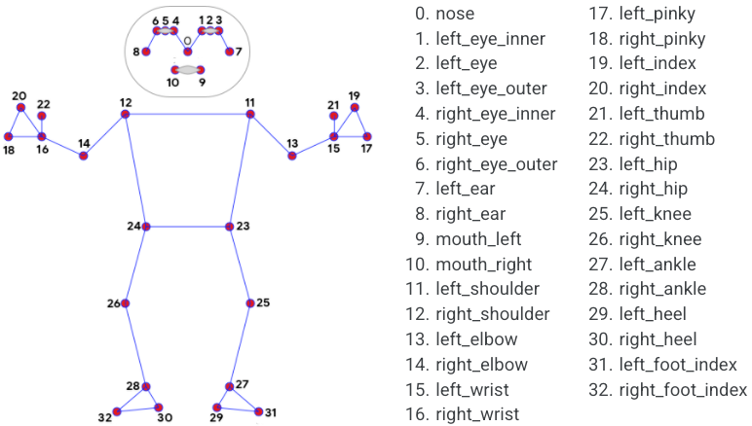

*Mapping of all landmarks on the body*

Next, we record the values of these coordinates over 11 frames, giving us 10 samples of displacement and speed data. For displacement, we take the difference between the minimum and maximum values to get the maximum displacement. This is done to differentiate random jitter from actual movement. To get the speed, we take the sum up the distance between each consecutive frame and take the average distance, then convert this to a speed with the frames per second and the frames sampled. The formula is as follows:

(distance1 + distance 2 + … + distance 10) / (sample size \* fps-1)

With these values, we can detect rapid movement of shoulders and head, so the next step is to detect rapid movement over a prolonged period. If the speed and displacement of the shoulders or head exceed a threshold (speed threshold is .5, displacement threshold is .03), a fixed value is added to a respective warning level variable, otherwise a value is subtracted from it If the warning level is above 80, then a warning is displayed for the shoulders or head.

If both values are above 80, then a seizure is considered to have started. The time that this happened is stored, and the seconds elapsed since the seizure started is displayed for the entire duration. Once at least one of the warning values falls below 80, the end time is stored, and the duration is set. Until a seizure starts again, the duration of the most recent seizure is displayed. A new seizure beginning will then display the duration in the same manner as before.